**Title: Containerizing Pyspark and tweet queries.**

**Members**:

**Name**

1) Mastan Krishna Neeraj Padarthi

2) Harish Tata

4) Saran Akkiraju



**Step1**: Unzip the above file to a location. The unzipped folder consists of 3 files which are Tweet file, Docker file and Source Code.

**Step2**: Assuming that docker is installed, open the terminal from the above folder and execute the below commands.

**Step3**: Docker build

**docker build -t crickettweetsqueries .**

Below is the output

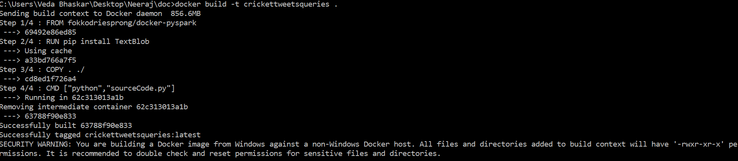

**Step4**: Check the image.

**Docker image ls**

Below is the output



**Step5**: Run the image

**docker run crickettweetsqueries**

Below is the output

